# Statistic Test: Analysis of Variance (ANOVA)

Overall Objective of this Study:

Is there a significant difference for hours played on average each month between the players of different levels?

The independent variable will be the level of players grouped by bracket. The dependent variable will be HRS1 which contains the number of hours played by month for players who answered the survey.

**Descriptive Statistics**

First, let’s look at the averages, standard deviation and confidence intervals for each group.

|  |  |  |  |  |  |  |  |  |  |  |  |
| --- | --- | --- | --- | --- | --- | --- | --- | --- | --- | --- | --- |
|  |  |  |  |  |  | **Descriptives (stats)** *hrs1* | | |  |  |  |
|  |  |  |  |  |  |  |  | |  |  |  |
|  |  |  |  |  |  |  | 95% confidence interval for Mean | | |  |  |
| Group # | Level bounds | | N | Mean | Std.Deviation | Std. Error | Lower Bound | Upper Bound | | Minimum | Maximum |
| *0* | 1 | 10 | 95 | 36.82 | 14.257 | 1.463 | 33.92 | 39.73 | | 5 | 87 |
| *1* | 11 | 20 | 463 | 42.20 | 13.041 | 0.606 | 41.01 | 43.39 | | 3 | 89 |
| *2* | 21 | 30 | 75 | 41.97 | 13.776 | 1.591 | 38.80 | 45.14 | | 4 | 80 |
| *3* | 31 | 40 | 191 | 44.28 | 14.075 | 1.018 | 42.27 | 46.29 | | 5 | 89 |
| *4* | 41 | 50 | 80 | 47.29 | 14.185 | 1.586 | 44.13 | 50.44 | | 6 | 80 |
|  | Total | | 904 | 42.50 | 13.754 | 0.457 | 41.61 | 43.40 | | 3 | 89 |

1. **Please interpret this table.**

|  |
| --- |
|  |

To analyze the distribution of HRS1 values per group, we look at the graph of error bars:

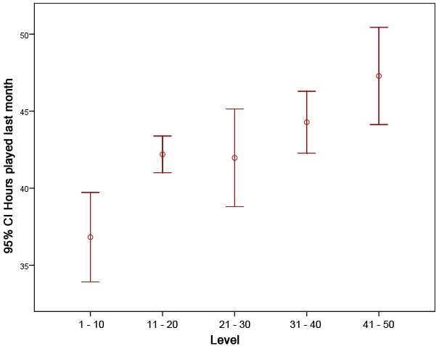

1. **Please interpret this graph**

|  |
| --- |
|  |

**Variances homogeneity**

Before looking at the results of the ANOVA, it is important to check the assumption of equality of variances with the test of Levene:

|  |  |  |  |
| --- | --- | --- | --- |
|  | **Levene's Test for equality of Variances** | |  |
| Levene Statistic | df1 | df2 | Sig. |
| 1.179 | 4 | 899 | 0.319 |

1. **Please interpret this table**

|  |
| --- |
|  |

**Results of the ANOVA**

Let’s look now at the results of the ANOVA:

|  |  |  |  |  |  |
| --- | --- | --- | --- | --- | --- |
|  |  | **Anova** |  |  |  |
|  |  |  |  |  |  |
|  | Sum of Squares | df | Mean Square | F | Sig. |
| Between groups | 5,567.843 | 4 | 1,391.961 | 7.572 | •000 |
| Within Groups | 165,264.140 | 889 | 183.831 |  |  |
| Total | 170,831.982 | 903 |  |  |  |

1. **Please interpret this table**

|  |
| --- |
|  |

**Multiple Comparisons**

Following this analysis of variance, it’s needed to do a post-hoc test.

Explain why and interpret the following table:

|  |  |  |  |  |  |
| --- | --- | --- | --- | --- | --- |
| Level (I) / Level (J) | Mean Difference (l-J) | Std. Error | Sig. | 95% confidence interval for Mean | |
| Lower Bound | Upper Bound |
| 0 - Level 1 - 10/ 1 - Level 11 - 20 | **-5,37\*** | 1.527 | 0.005 | -9.67 | -1.08 |
| 2 - Level 21 - 30 | -5.152 | 2094, | 0.141 | -11.05 | 0,74 |
| 3 - Level 31 - 40 | -7,462* | 1.702 | .000 | -12.25 | -2.67 |
| 4 - Level 41 - 50 | -10,466* | 2057, | .000 | -16.26 | -4.68 |
| 1 - Level 11 - 20/ 0 - Level 1 - 10 | **5,37\*** | 1.527 | 0.005 | 1.08 | 9.67 |
| 2 - Level 21 - 30 | 0.223 | 1.688 | 1.000 | -4.53 | 4.97 |
| 3 - Level 31 - 40 | -2.086 | 1.166 | *0.739* | -5.37 | 1.19 |
| 4 - Level 41 - 50 | -5,091* | 1.642 | .020 | -9.71 | -0.47 |
| 2 - Level 21 - 30/ 0 - Level 1 - 10 | 5.152 | 2.094 | 0.141 | -0.74 | 11.05 |
| 1 - Level 11 - 20 | -0.223 | 1.688 | 1.000 | -4.97 | 4.53 |
| 3 - Level 31 - 40 | -2.309 | 1.848 | 1.000 | -7.51 | 2.89 |
| 4 - Level 41 - 50 | -5.314 | 2.179 | 0.149 | -11.45 | 0,82 |
| 3 - Level 31 - 40/ 0 - Level 1 - 10 | 7,462* | 1.702 | .000 | 2.67 | 12.25 |
| 1 - Level 11 - 20 | 2.086 | 1.166 | *0.739* | -1.19 | 5.37 |
| 2 - Level 21 - 30 | 2.309 | 1.848 | 1.000 | -2.89 | 7.51 |
| 4 - Level 41 - 50 | -3.005 | 1.806 | 0.964 | -8.09 | 2.08 |
| 4 - Level 41 - 50/ 0 - Level 1 - 10 | **10,466\*** | 2.057 | .000 | 4.68 | 16.26 |
| 1 - Level 11 - 20 | **5,091\*** | 1.642 | .020 | 0.47 | 9.71 |
| 2 - Level 21 - 30 | 5.314 | 2.179 | 0.149 | -0.82 | 11.45 |
| 3 - Level 31 - 40 | 3.005 | 1.806 | 0.964 | -2.08 | 8.09 |

**ANSWER**

|  |
| --- |
|  |